Task on monitoring

- Enable cloudtrail monitoring and store the events in s3 and cloudwatch log events.
Ans: Task Title :
Enable CloudTrail and Store Logs in S3 & CloudWatch Logs
Objective :
Enable AWS CloudTrail to monitor all API events and store them securely in S3 and
CloudWatch Logs for auditing and monitoring.
Prerequisites :
• IAM Admin / CloudTrail permissions
• S3 bucket (CloudTrail can create)
• CloudWatch Log Group / IAM role for CloudTrail
Step-by-Step Implementation (With Evidence)
First we need to login to aws console then search for cloud trail and create a trail as default 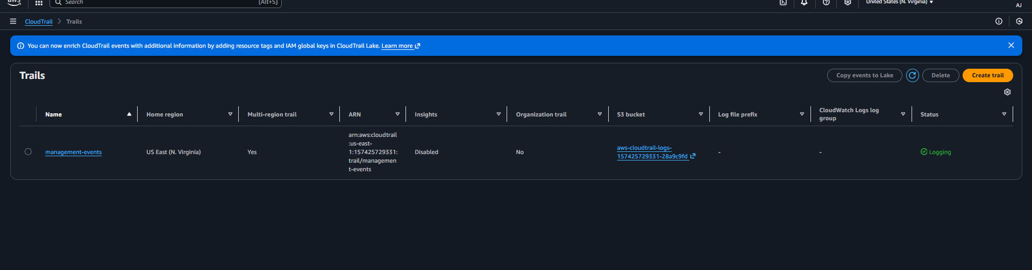and then need to click on create trail again
But before that creating a bucket so search for s3 in aws console and created a bucket 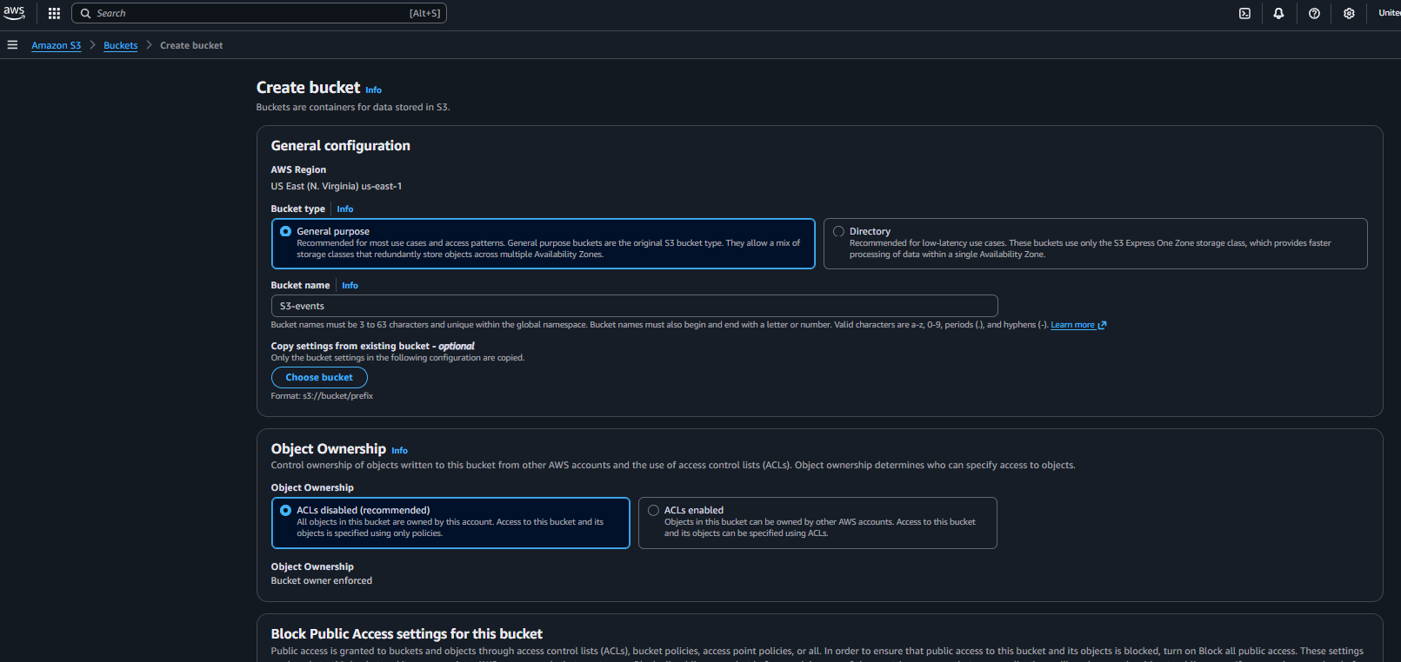
Then came to cloudtrail and created for existing s3 bucket and selected for management event and disable the encryption 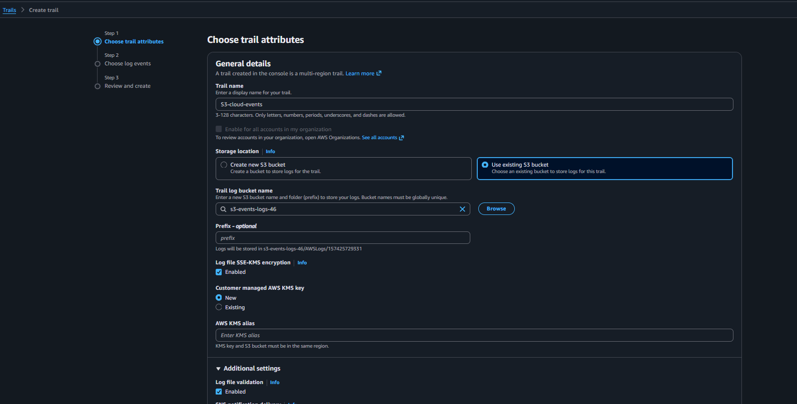and click on next and created the event successfully 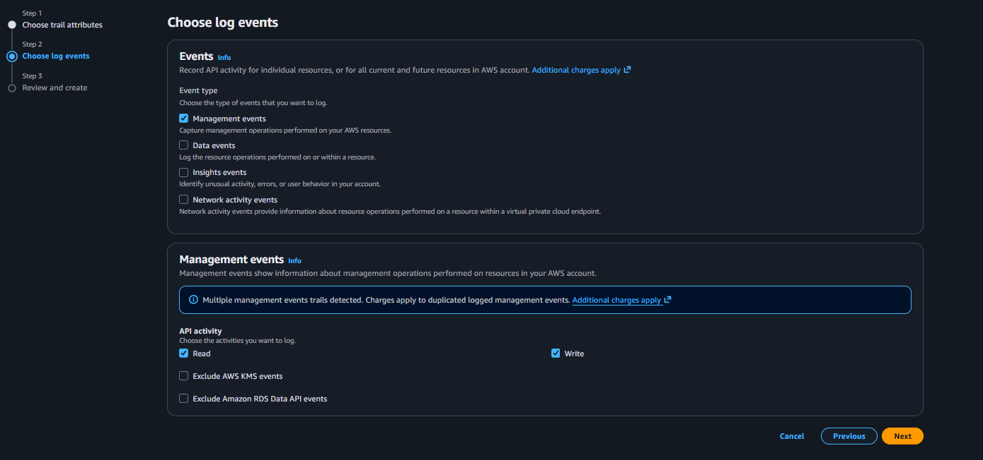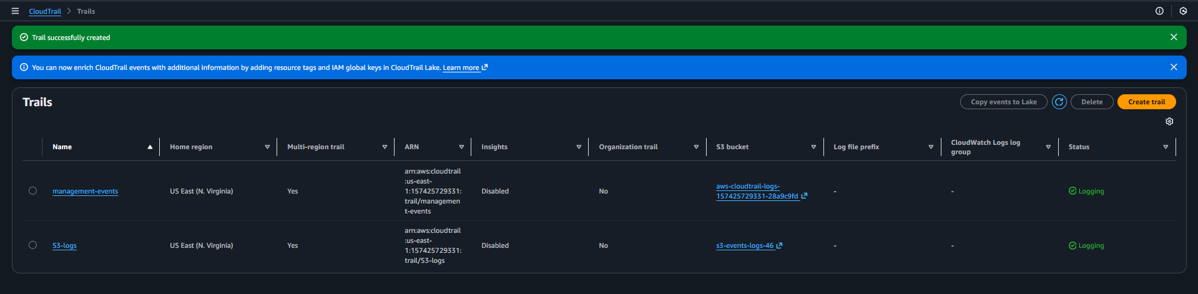
Now if we check on s3 bucket we can see the event logs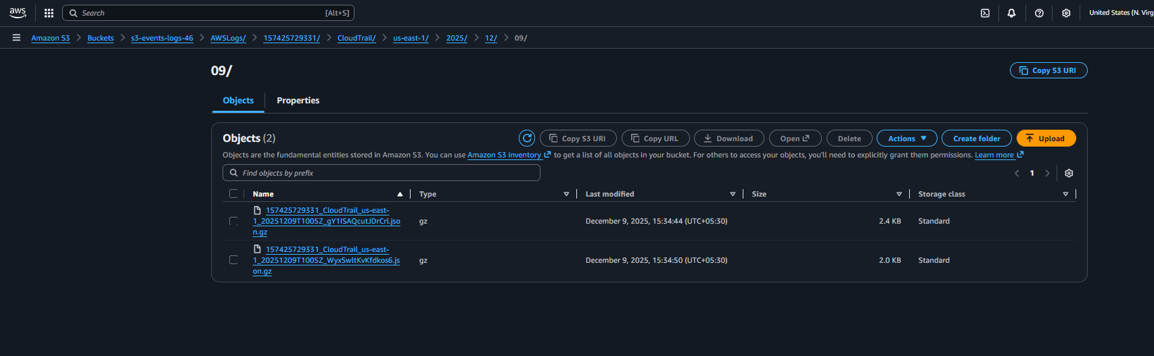

Next for cloudwatch creating a new event and enabling the cloudwatch logs and entre the new IAM role not added the existing IAM role entre the IAM role 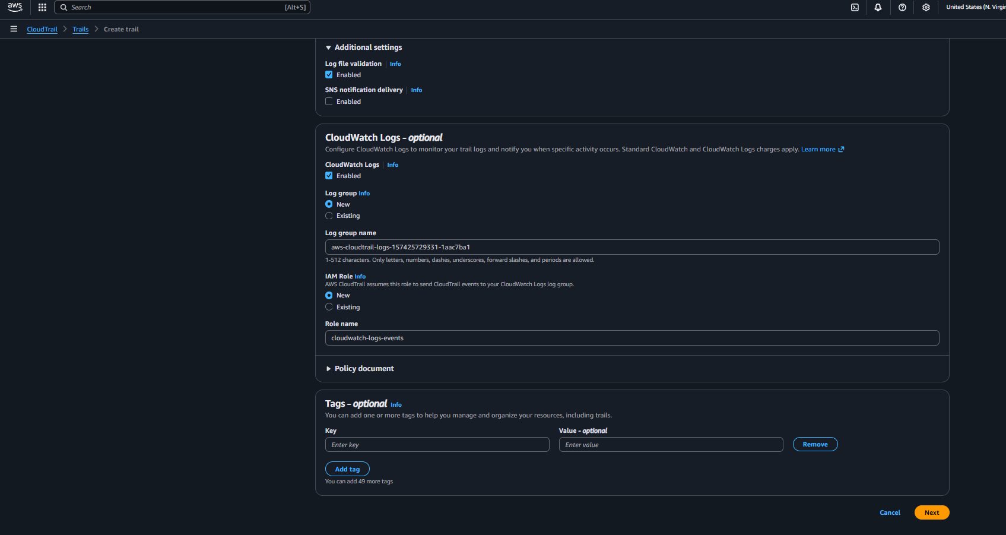
Then need to click on next and created the cloudwatch logs event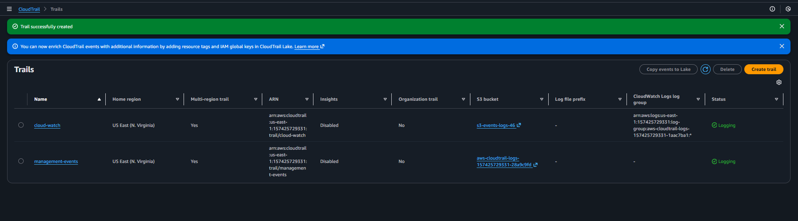

Validation Steps (With Evidence):
Search for s3 in aws console and open the bucket and check cloudtrail-logs in bucket

Then check for cloudwatch and check the management logs shows on that service 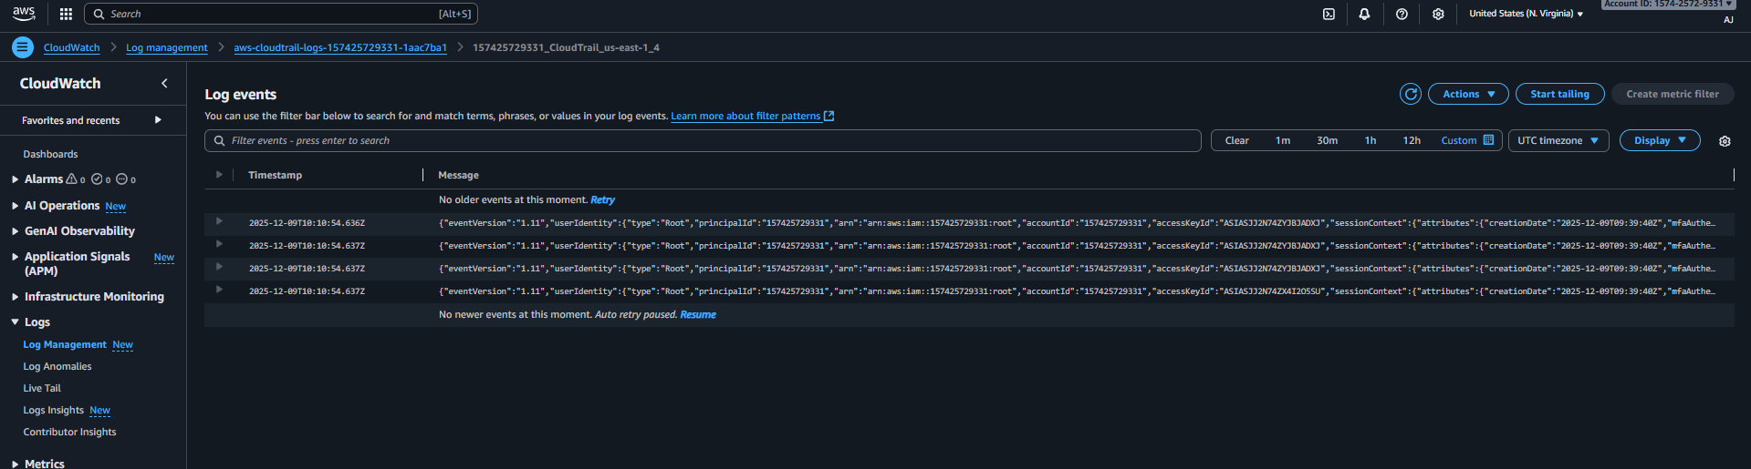
Successfully created events for S3 and couldwatch.

- Enable SNS for cloudtrial to send alert on email.
Ans: Task Title :
Enable SNS Alerts for CloudTrail Using CloudWatch Metric Filters
Objective :
Send email notifications for critical CloudTrail events (e.g., unauthorized API calls).
Prerequisites :
• CloudTrail enabled
• CloudWatch Logs enabled
• Valid email address
• IAM SNS permissions

Step-by-Step Implementation (With Evidence)
First need to create sns we have to search for simple notification services inaws console 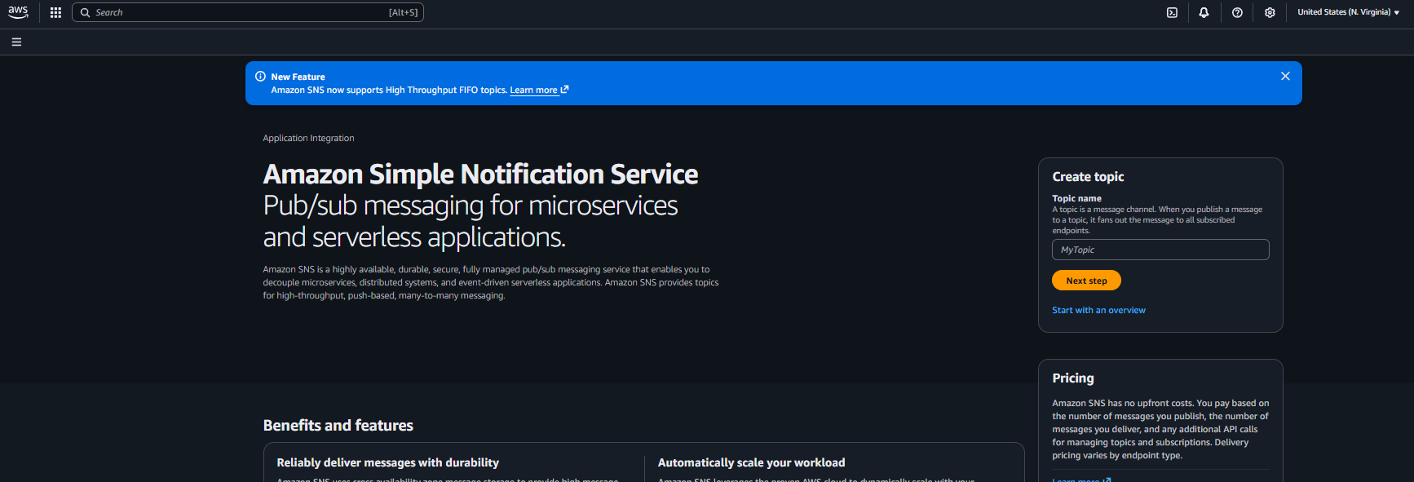
Then need to click on next step and select for standard and need to click on create topic 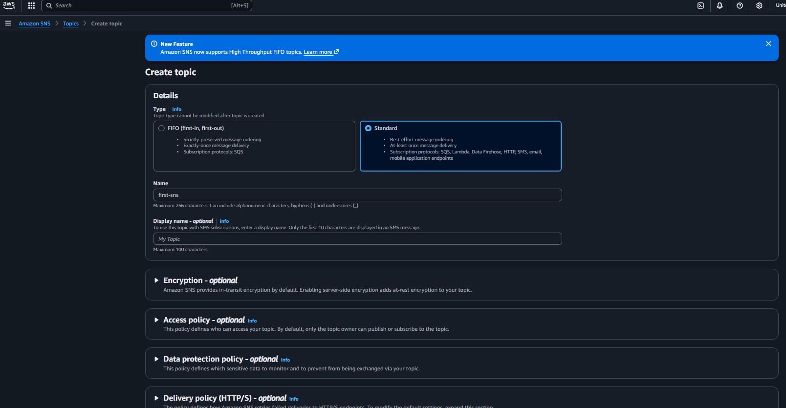
Once it got created then we need to click on create the subscription and select for email and click create it got created 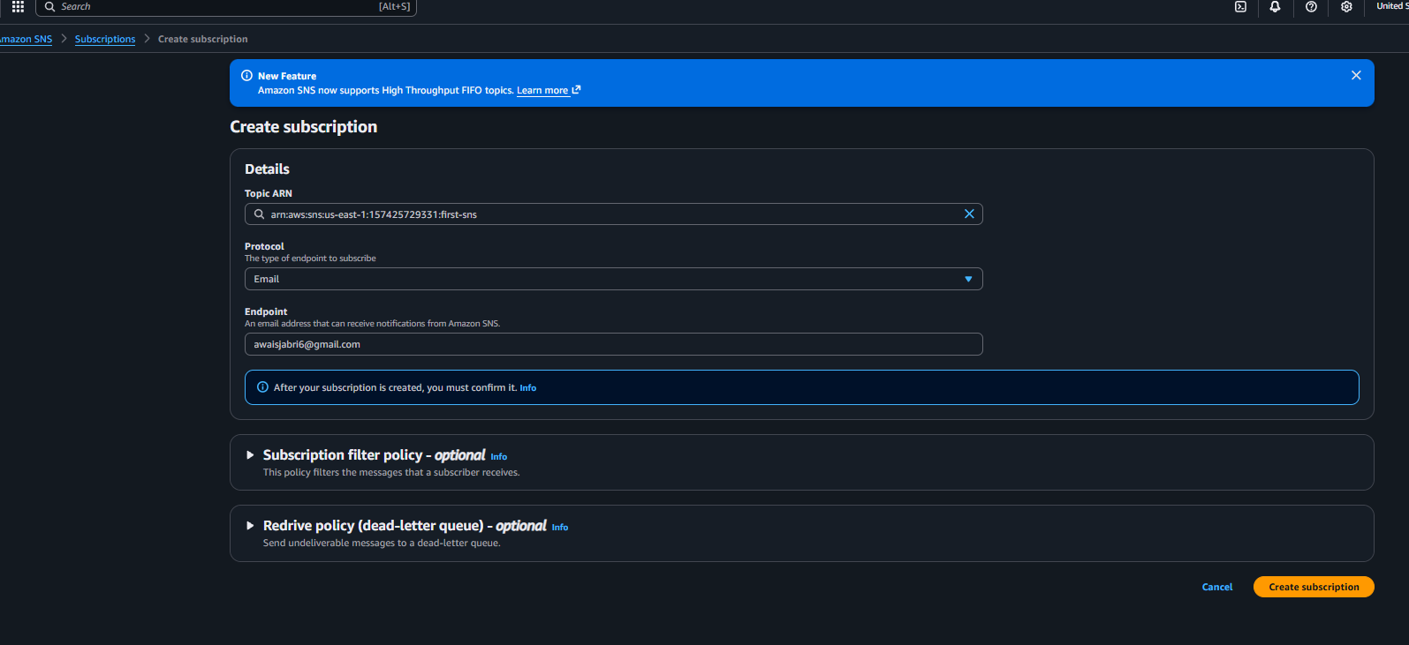
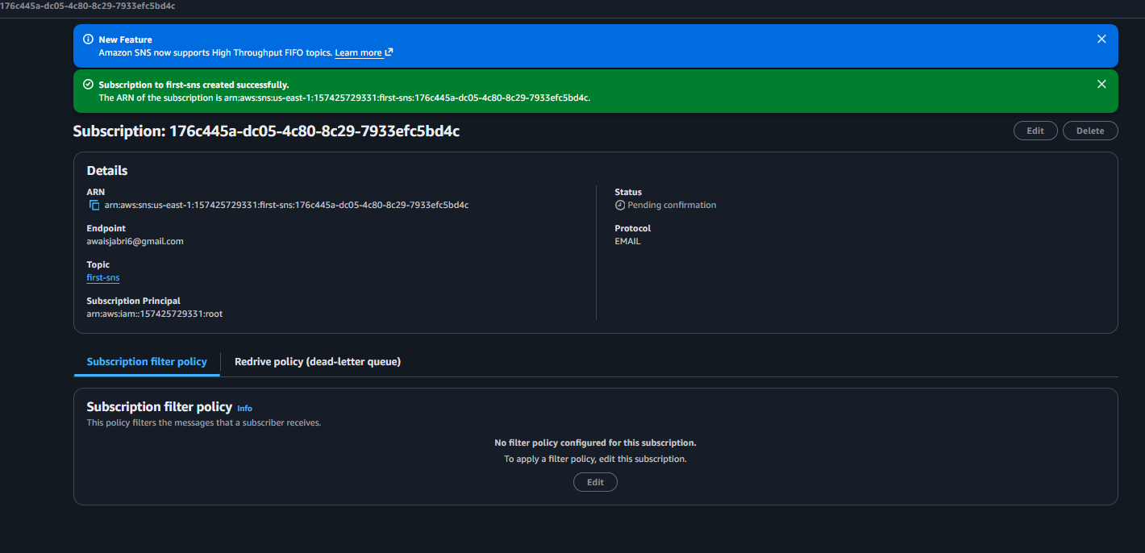
Then need top open the email and confirm the subscription
Then creating the trail in cloudtrail with enabling the sns and added created the trail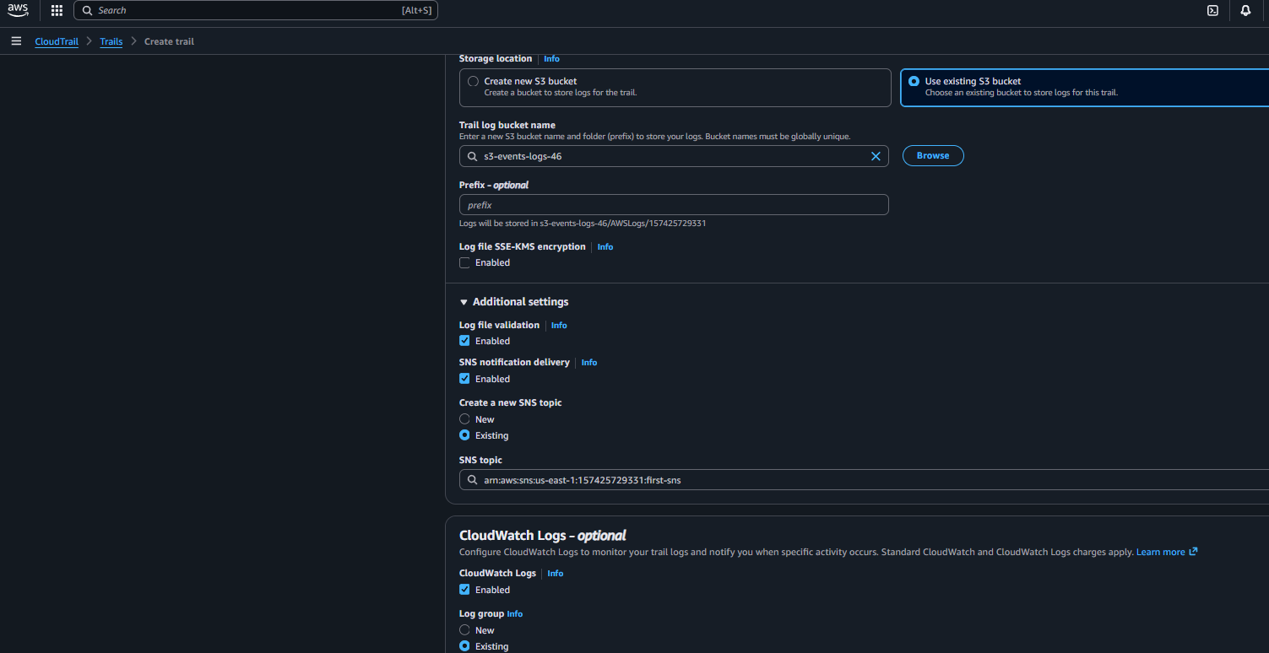

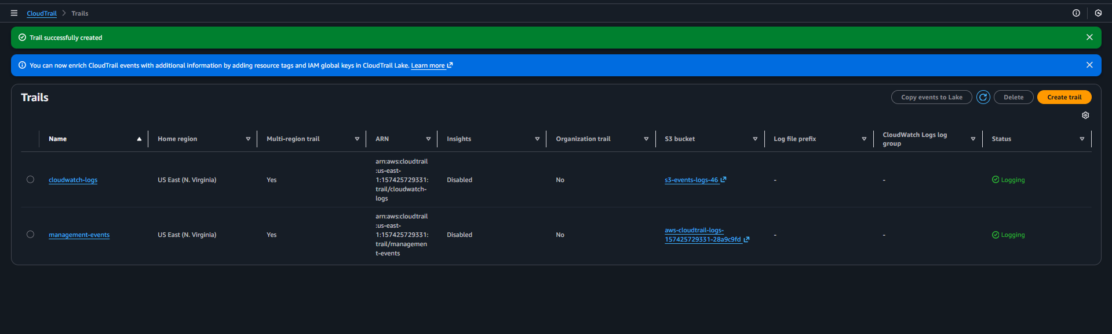

Validation Steps (With Evidence):
Successfully created the sns 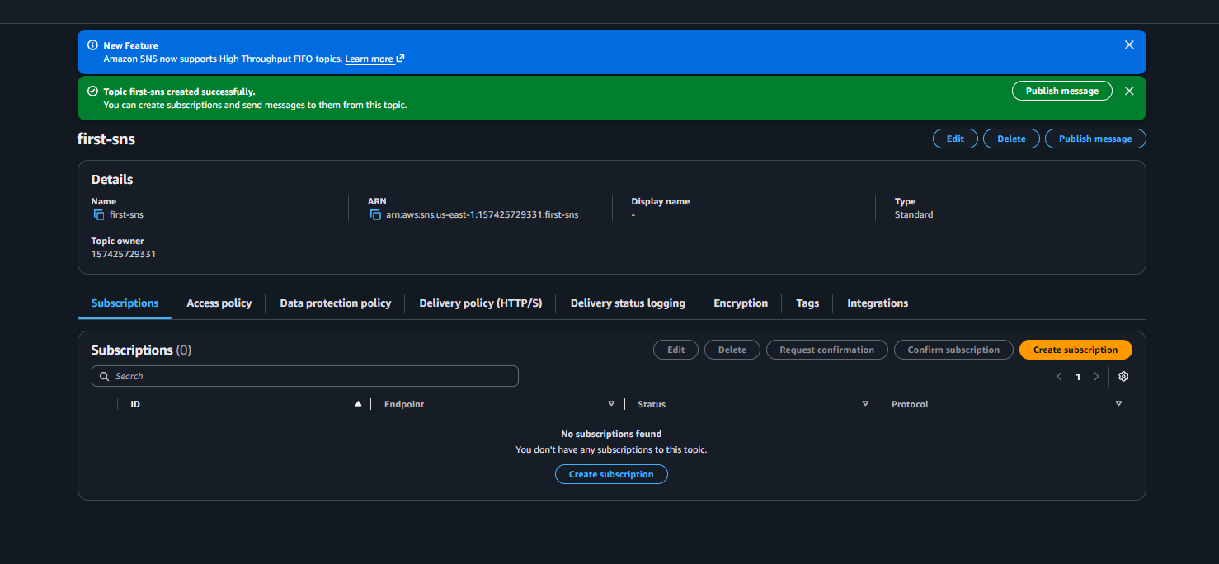
Then accepted the conformation of sns through the email 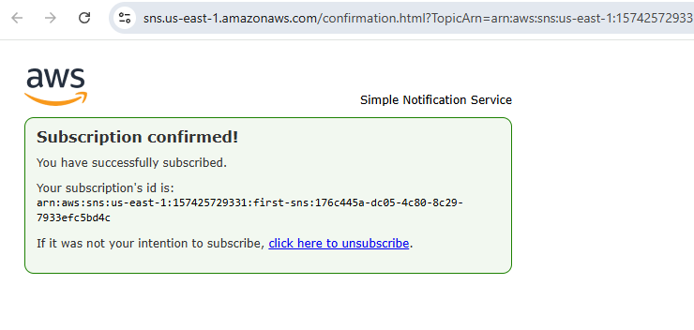
And while created new trail by enabling the sns  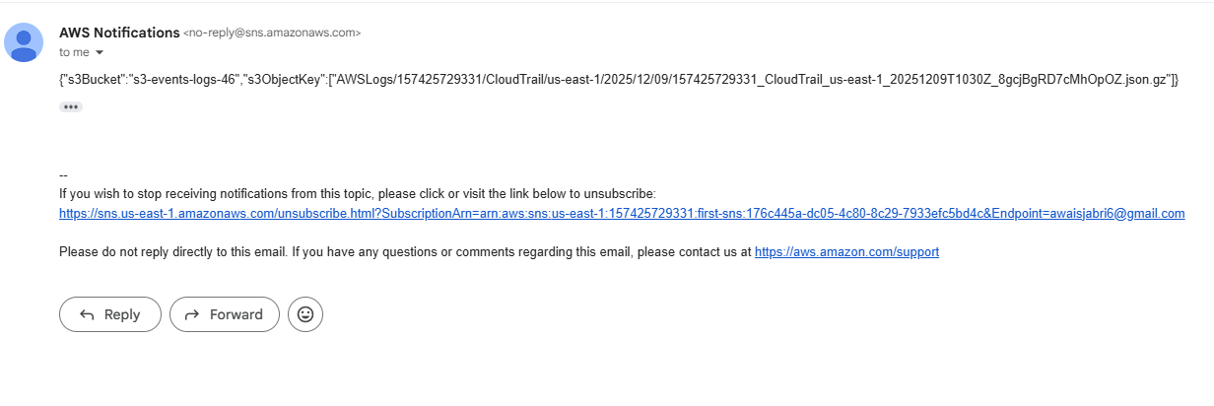
Successfully sns is been assocated with cloudtrail.

- Configure cloud watch monitoring and record the cpu utilization and other metrics of ec2.
Ans: Task Title :
Install & Configure CloudWatch Agent on EC2 for System Monitoring
Objective :
Collect CPU, Memory, Disk, and EC2 status metrics using CloudWatch Agent.
Prerequisites :
• EC2 instance
• SSH Access
• Internet access (or SSM)
Step-by-Step Implementation (With Evidence):
First need to launch one instance 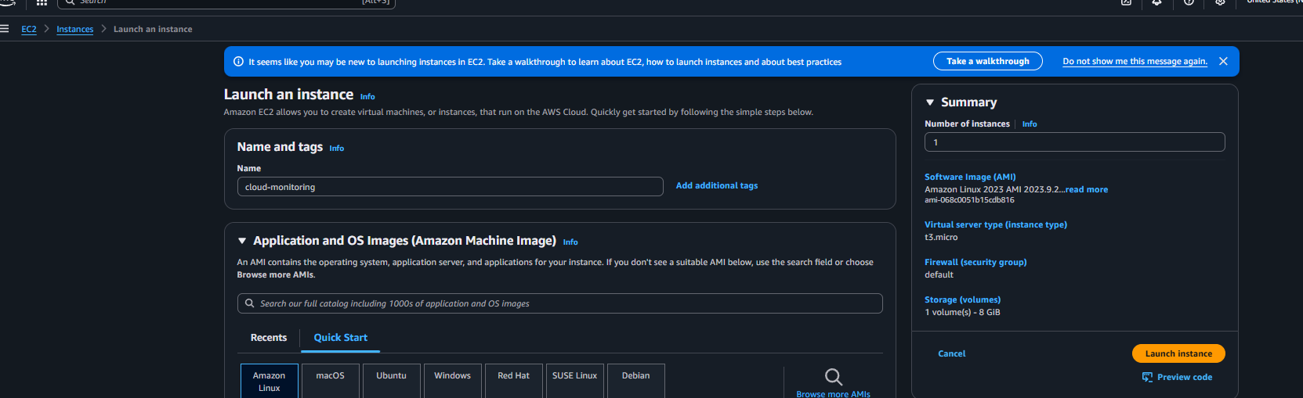
Once the instance is been created needed to go for cloudwatch and create a dashboard and selected for cpu utilization 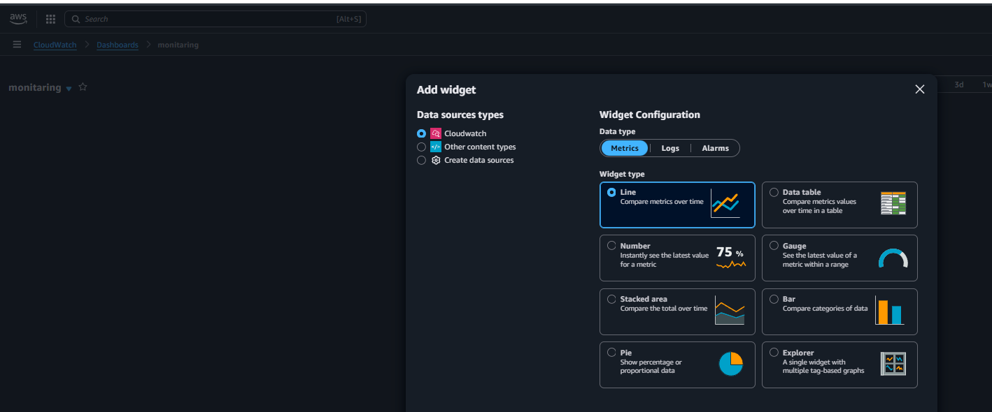
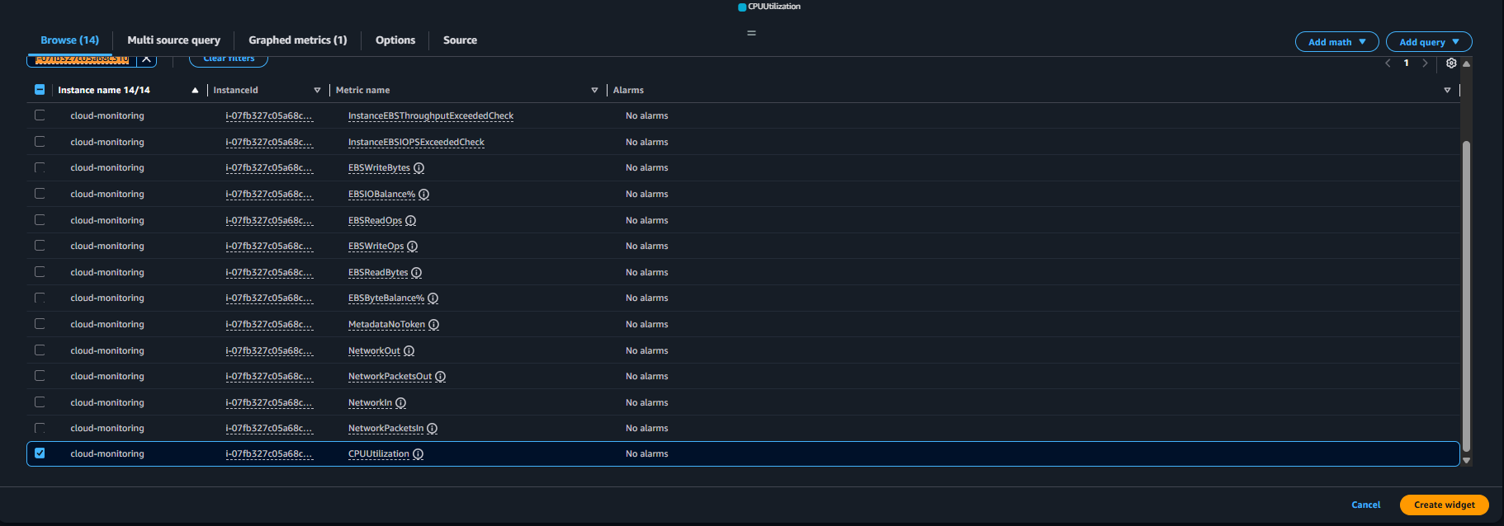

Once it got created save the widget and click on add and create 2 more widget 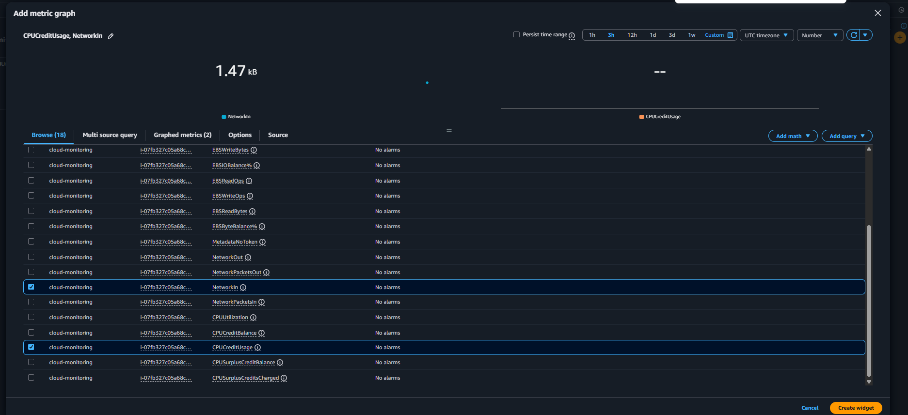

Validation Steps (With Evidence):
Created ec-2 instance successfully and clear 3/3 checks 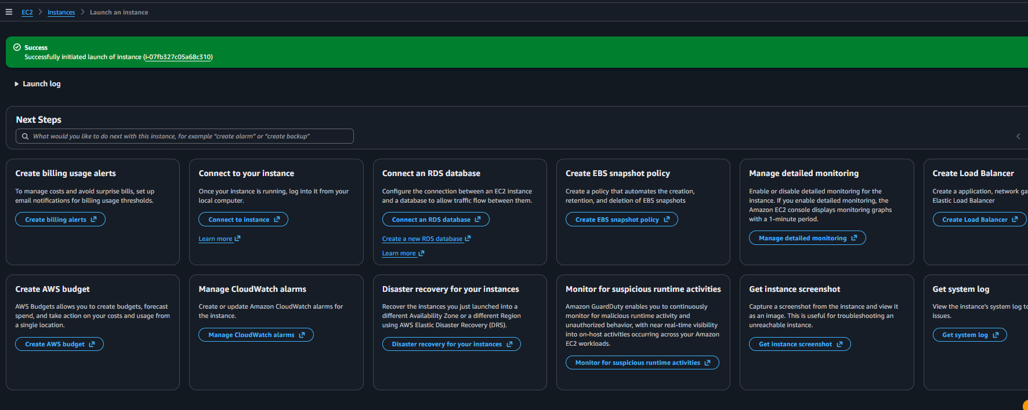 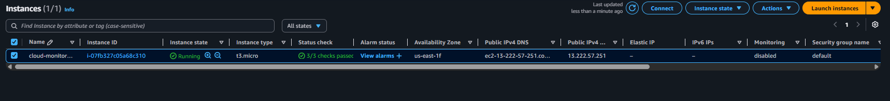
Created dashboard and added one cpu utilization 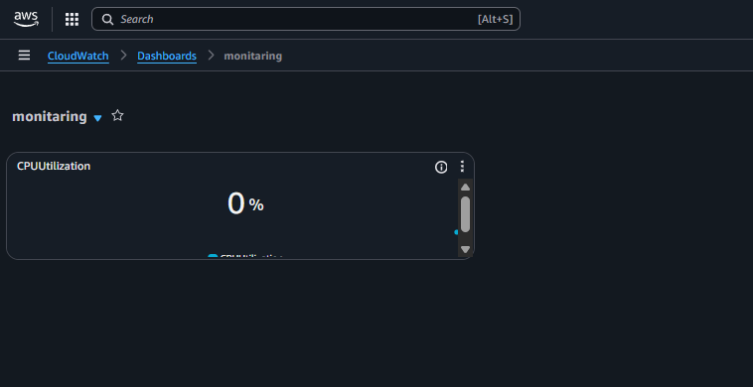
Added 2 more widgets under the dashboards 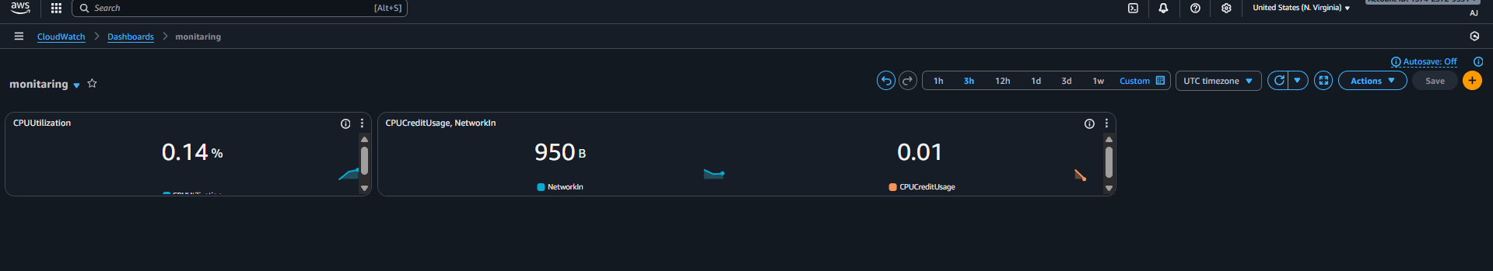

Successfully configure the cloudwatch monitaring and added 3 widget under the cloudwatch dashboard.

04) one alarm to send alert to email if the cpu utilization is more than 70 percent.
Ans: Task Title :
creating one alarm to get alert email notification for cpu utilization if its more than 70%
Prerequisites :
• Cloudwatch Alarm
• EC2 instance
• SSH Access
• Internet access (or SSM)
Step-by-Step Implementation (With Evidence):
First need to create one alarm for cpu utilization grater than 70%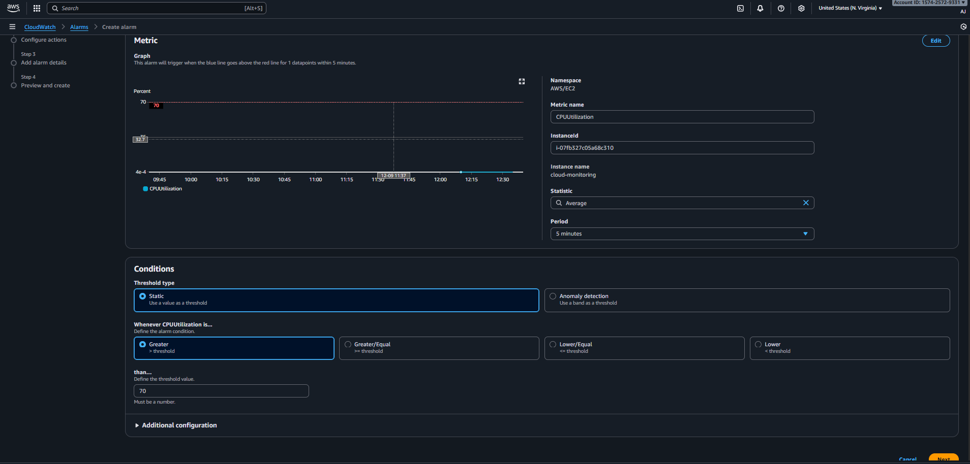
Now accessing ec-2 instance to add some load 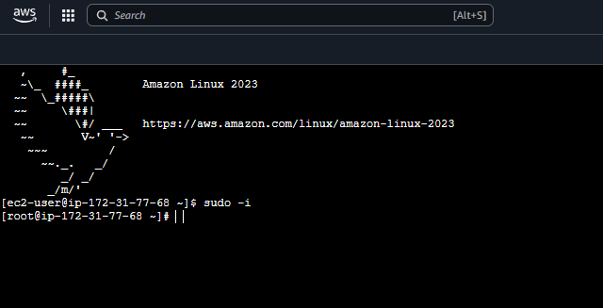
Now first we need to install the one package to add some load (sudo yum install stress -y) 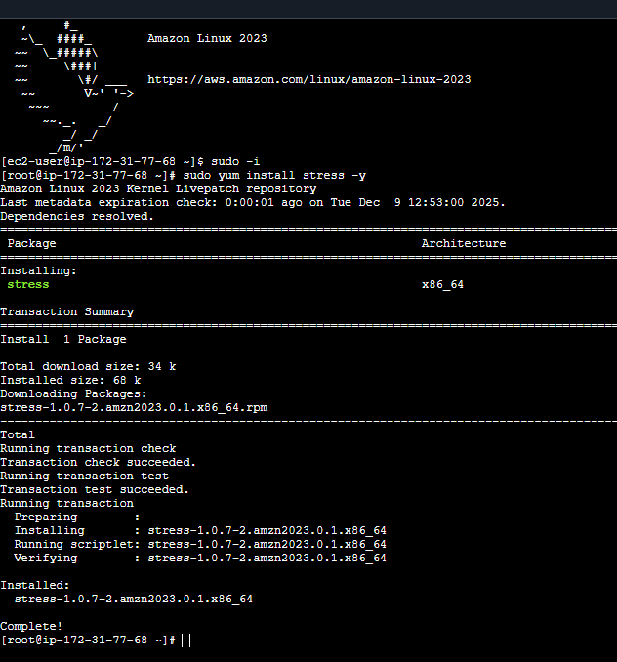
Then need to enter the command (yes > /dev/null &)to add some load 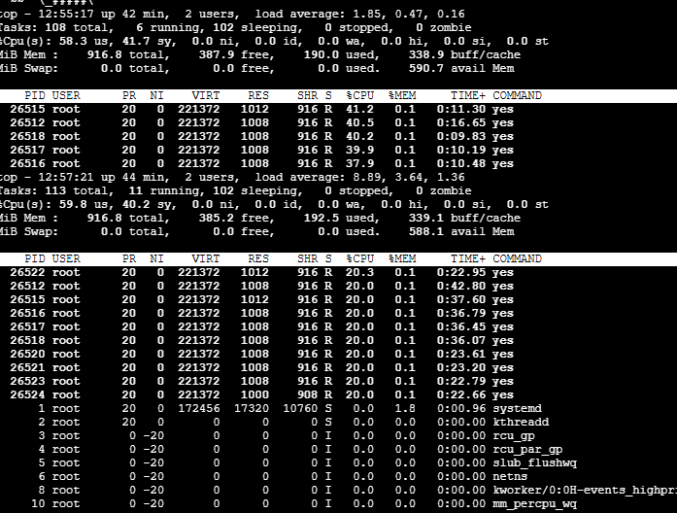
Now cpu utilization is more than 70% if we check wi’ll receive email alert 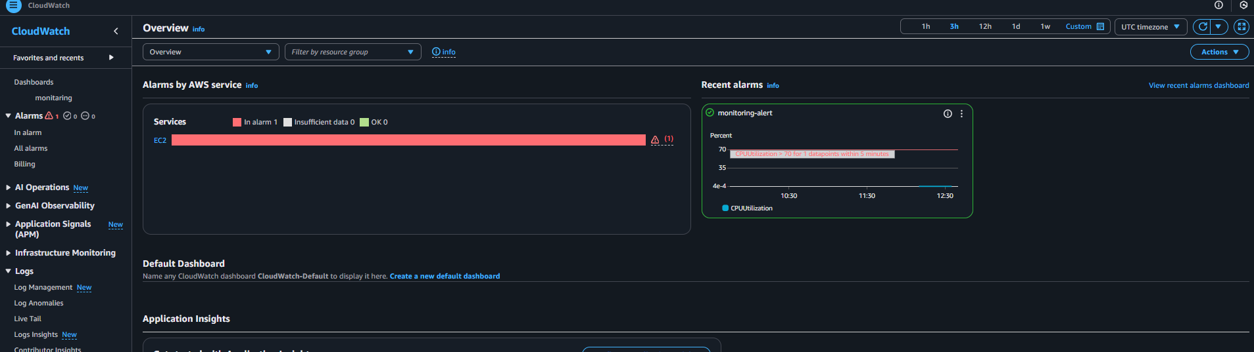

Validation Steps (With Evidence):
First created alarm successfully 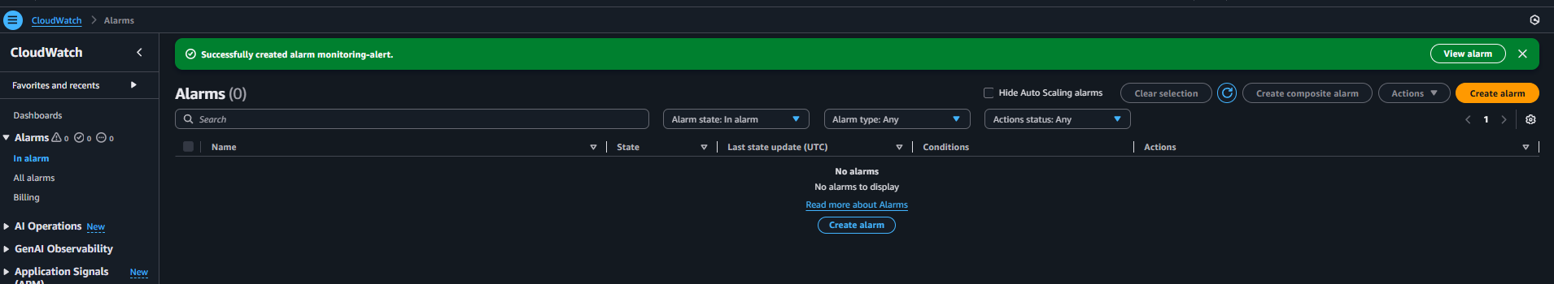
And conform the email subscription 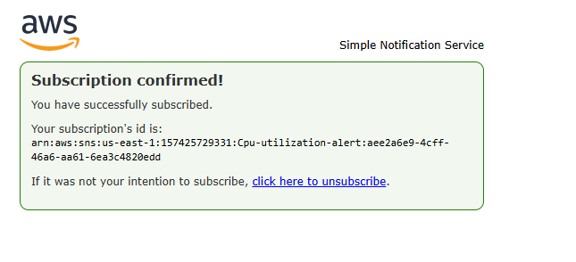
Received email alert for cpu utilization for more than 70%
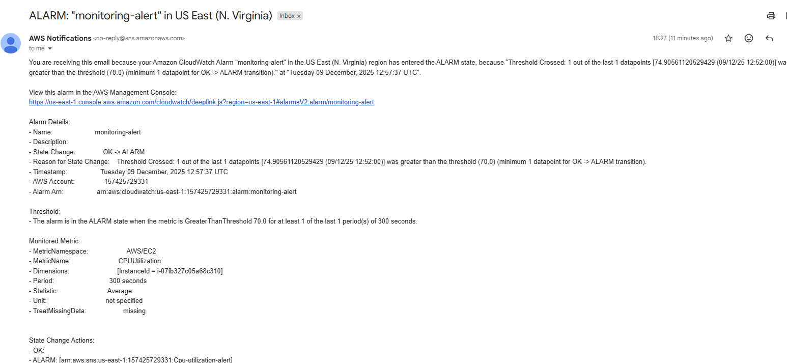

04) Create Dashboard and monitor tomcat service wether it is running or not and send the alert.
Ans: Task Title :
Monitor Tomcat Service Using Custom CloudWatch Metrics
Objective :
Track Tomcat service uptime and trigger alerts if service stops.
Prerequisites :
• EC2 instance with Tomcat installed
• CloudWatch Agent or AWS CLI installed
• CloudWatch Alarm
Step-by-Step Implementation (With Evidence):
First need to connect the terminal to remote server 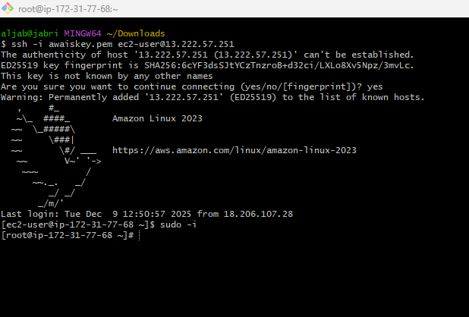
Once its connection is been build, we need to install the java
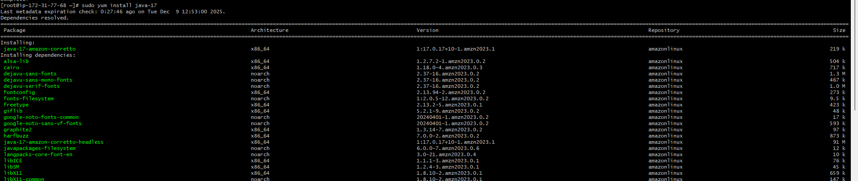
Then changed the directory (cd opt) and isntall the tomcat file (wget tomcat link) 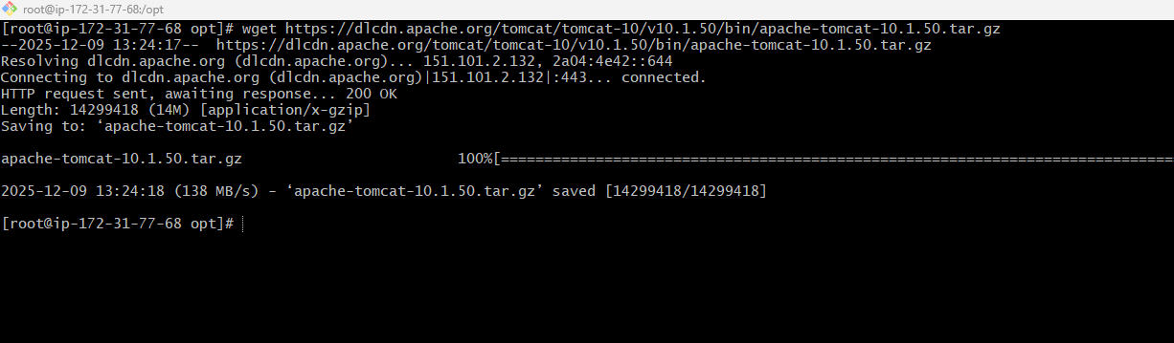
Now extract the file and rename the file name 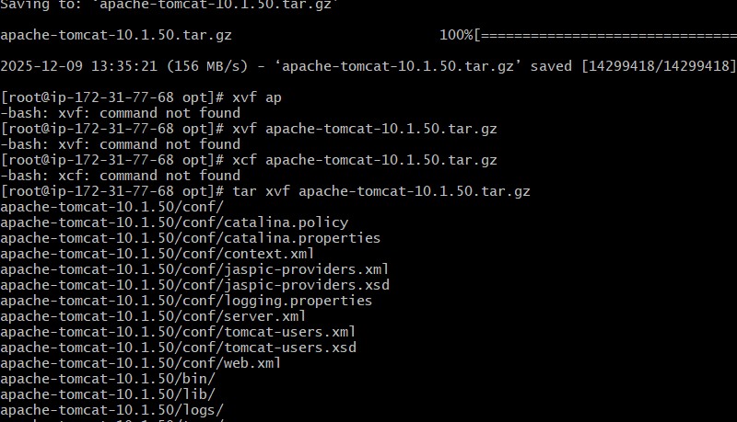
Then start the tomcat service and move to root directory and create the file and added the script 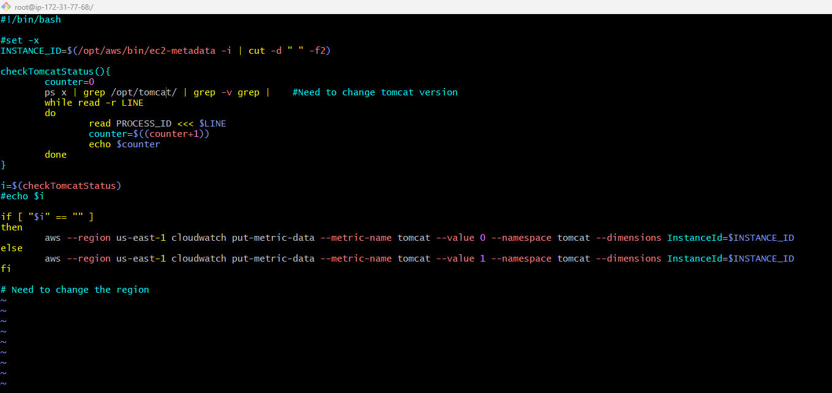

Then need to configure the aws cli and run the script 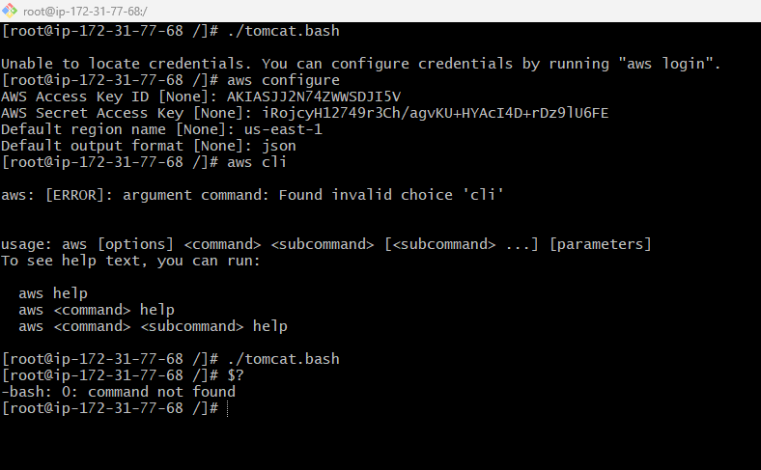
Now we have to create a dashboard for tomcat in cloudwatch 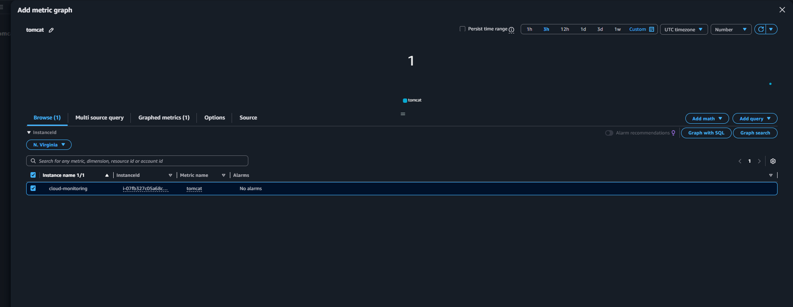
Then need to add alarm for tomcat service in cloudwatch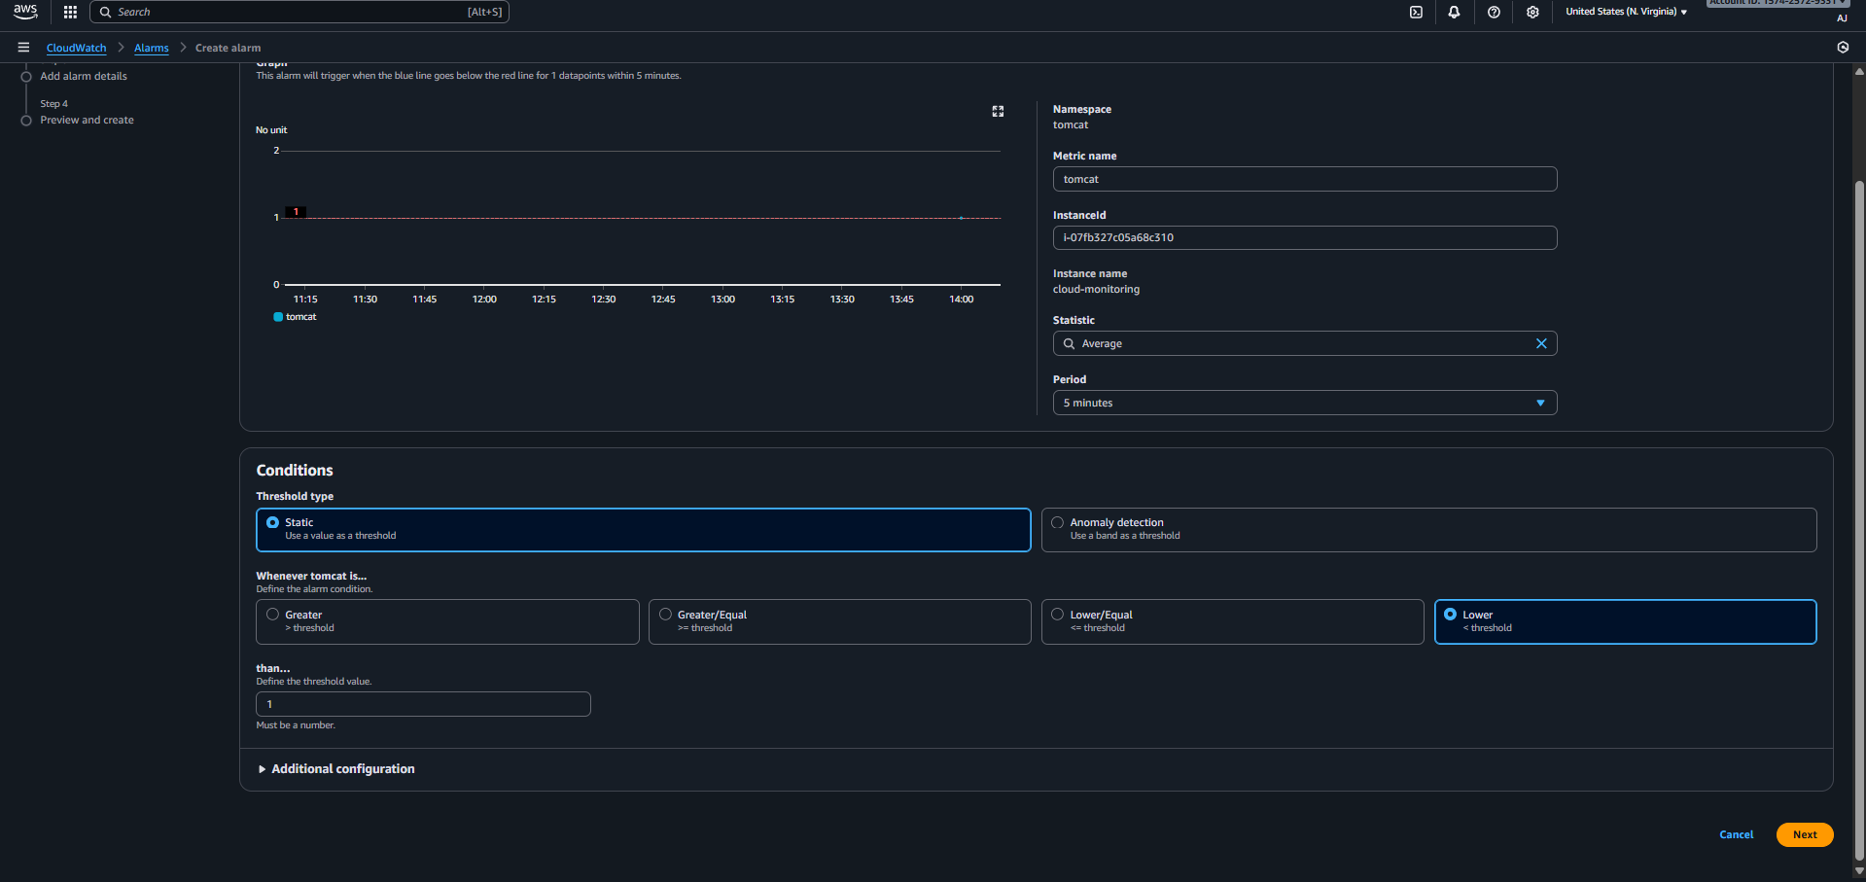
Added new topic for alarm alert and save the alarm 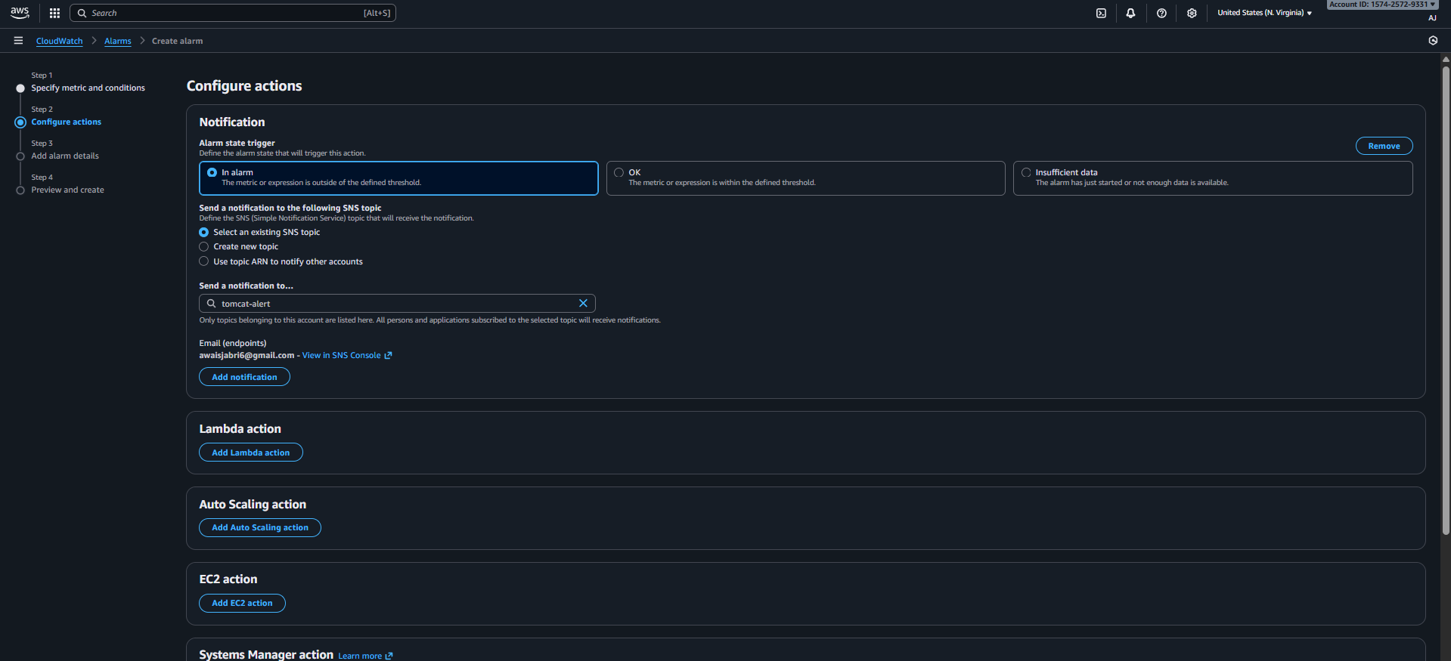

Now we have to add crontab in remote server for tomcat service scripting so we need to install by using command of (sudo yum install cronie -y) 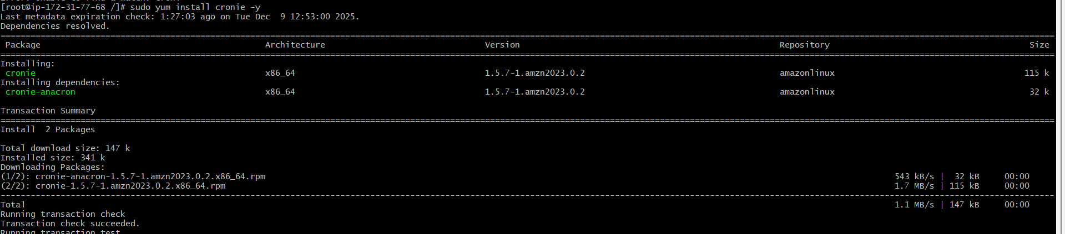
Then need to open file with (crontab -e) and add (* * * * * /root/tomcat.bash) save the file 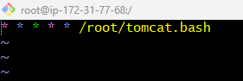
Now stopping the service of tomcat to check the email alert 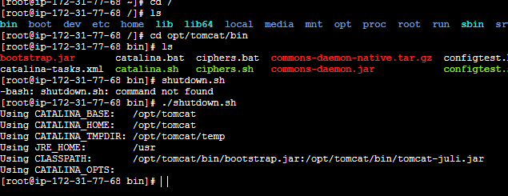

Now under the alarm the status is showing -- means tomcat service is been closed and email is been received

Evidence:
Connected to remote server successfully 
Installed the java 
Installed the tomcat 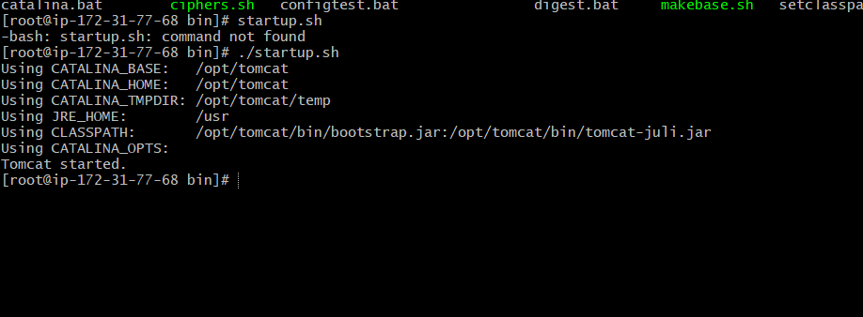
Created alarm for tomcat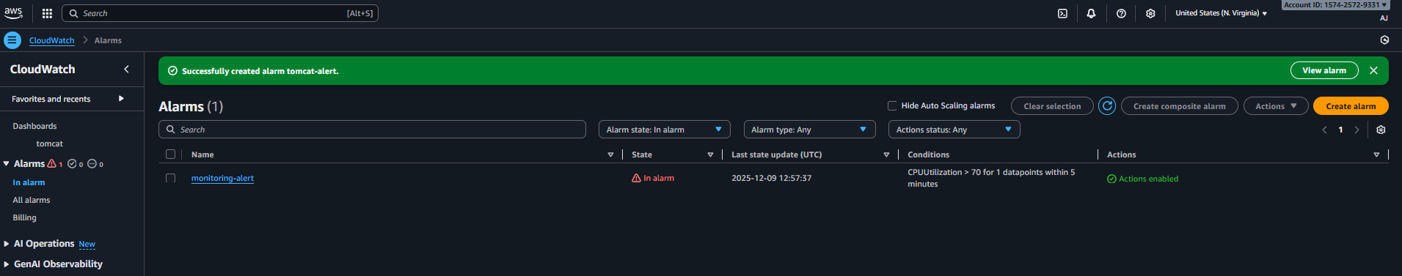
Confirm the sns 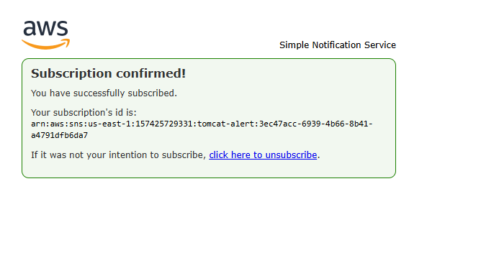
Install crontab
Tomcat is been shutdown 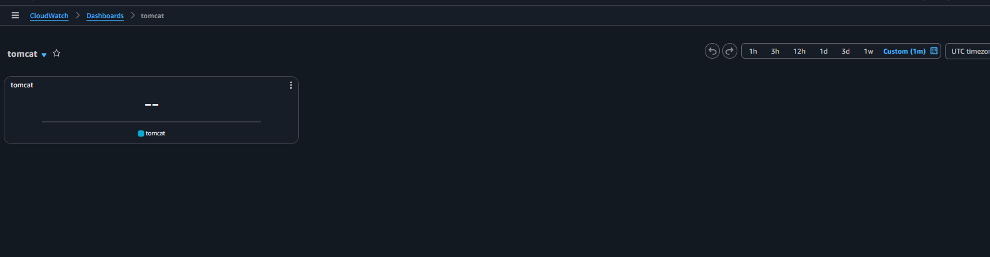
6) Create Dashboard and monitor nginx service to send the alert if nginx is not running.
Ans: Task Title :
Monitor Nginx Service Using Custom CloudWatch Metrics
Objective :
Monitor Nginx service health and receive alerts when it stops.
Prerequisites :
• EC2 with Nginx installed
• AWS CLI
• CloudWatch write permissions
Step-by-Step Implementation (With Evidence):
First need to install nginx 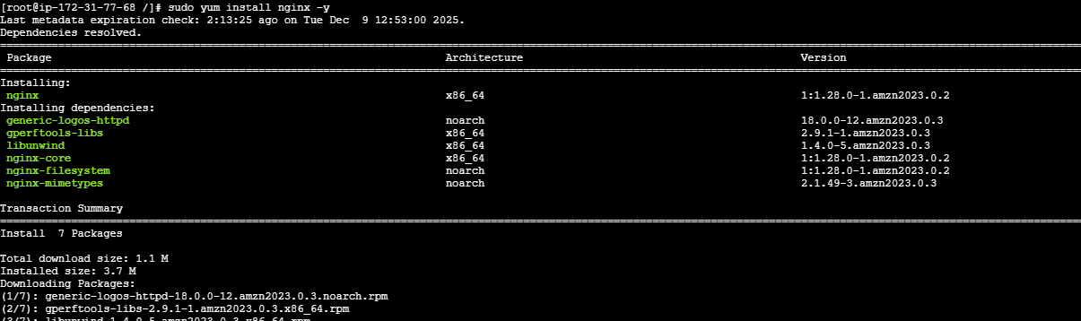
Then need to start the service with (systemctl start nginx) and create the bash script and added in the crontab 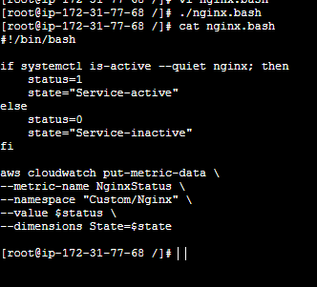

Now need to create a dashboard under the cloudwatch and add alarm 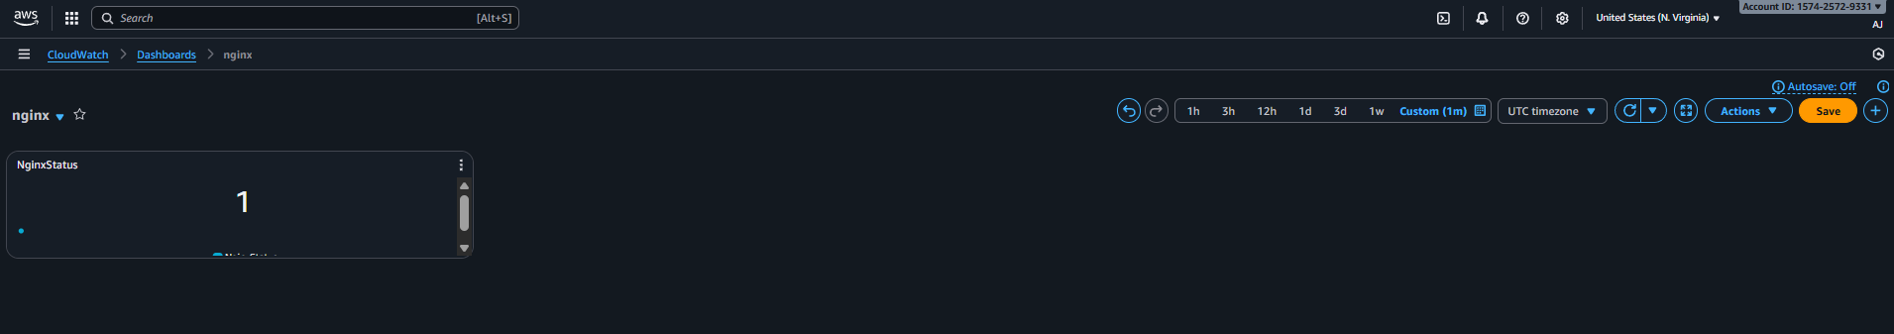
Successfully alarm is been created 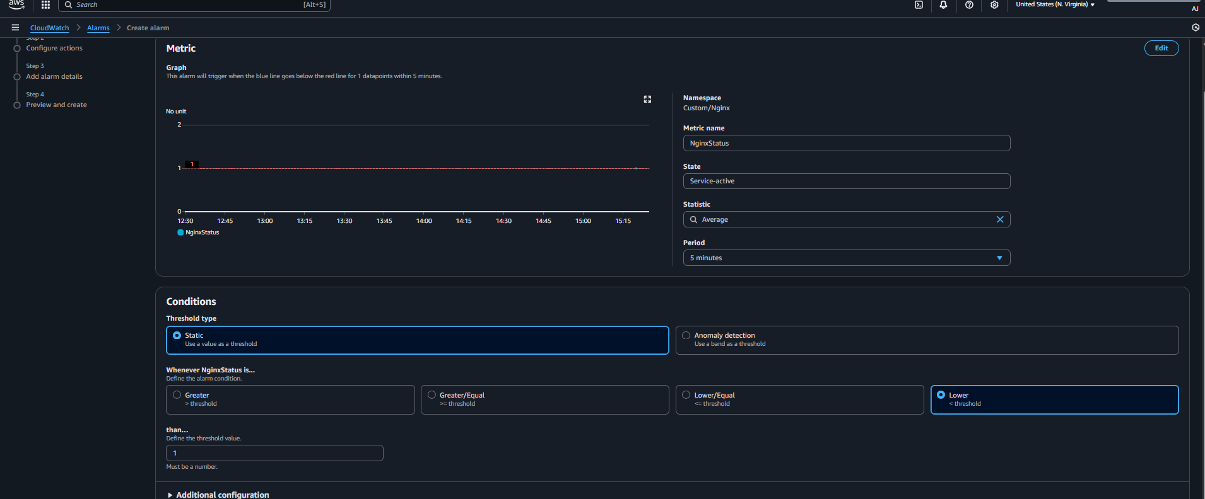

Evidence:
Installed nginx
Added the script


Alarm is been created to send the alert 

Created the monitoring alert for nginx services .

